**EXAMPLE PAGE’S ANALYSIS DOCUMENT**

Contents

DOCUMENT INFORMATIONS 1

Document History 1

WORK RULES AND REQUIREMENT DESCRIPTIONS 2

Page Defınıtıons 2

Warning and Error Messages 3

Page Design 4

Companents 4

# DOCUMENT INFORMATIONS

## Document History

|  |  |  |  |
| --- | --- | --- | --- |
| **Version** | **Date** | **Person** | **Descriptions** |
| 1.0 | 22.11.2022 | Mert Ali ULUDAĞ | * Creating the documents first version. |
|  |  |  |  |

# WORK RULES AND REQUIREMENT DESCRIPTIONS

## Page Defınıtıons

This page will be created for managing of the users information.

This page will be open from navigation bar.

This page will be accessible only for **Admin** and **SuperAdmin** roles.

The top of the pages will have **New User** **button**, **Hide Disabled User checkbox**. There will be table on the center of the page. This table will have **ID**, **User Name**, **Email** and **Enabled** columns. All of the column would be sorted ascending and descending order and filters.

**Roles Access Permissions Of Example Page**

If user want to do something without permission, warning message will appear on the page.

|  |  |  |  |
| --- | --- | --- | --- |
| Roles  Processes | SuperAdmin | Admin | Guest |
| Page Access | X | X |  |
| Create Guest User | X | X |  |
| Create Admin User | X | X |  |
| Create SuperAdmin | X |  |  |

Modal will be open after clicking than New User button.

New User modal will have **Username, Display Name, Phone, Email informations as text fields, User Roles as dropdown, Enabled checkbox** and **Save User button**. User Roles will have “**Select user roles...**” placeholder.

When checked Hide Disabled User checkbox, just Enabled columns true values rows will be list in table.

User Roles dropdown options will be **Guest, Admin** and **SuperAdmin** as users.

**Username, Display Name, Phone, Email, User Roles** fields will be **required fields**.

When Admin selecting the roles, SuperAdmin will be disable.

After clicking the Save User;

İf required fields are null it will give warning message, else the fields written and selected options will be save on database. After this process the page will be refresh.

## Warning and Error Messages

|  |  |  |  |
| --- | --- | --- | --- |
| Message Code | Error/Warning | Condition | Error/Warning Text |
| E01 | **Error** | * Guest user has want to join the Example Page. | You do not have access permission!  Ok |
| E02 | **Error** | * Admin user has want to create Super Admin User. | You do not have SuperAdmin create permission!  Ok |
| E03 | **Error** | * Did not writed or selected value to required fields. | Required fields can not be null!  Ok |
| W01 | **Warning** | * When the user clicked New User button. | Are you sure?  If you choose **Yes** you won't be going back!  Yes/No |
| W02 | **Warning** | * When the user filled all required fields and clicked Save User button. | Are you sure?  If you choose **Yes** you won't be delete user!  Yes/No |

# Page Design

Example Page’s Design

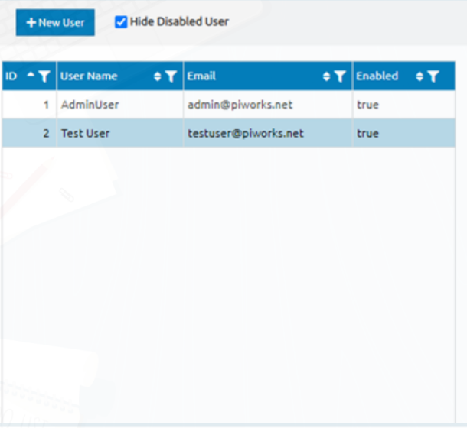When Example Page will be open, It will looks like left image.

New User Modal of Example Page’s Design

When 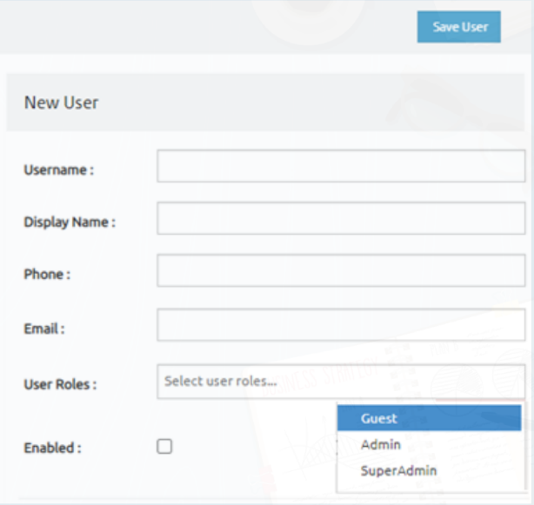clicked New User button and selected Yes for warning message, opened modal will looks like left image.

## Components

|  |  |  |  |
| --- | --- | --- | --- |
| Component Name | Type | Function | Image |
| New User | Button | * Opening W01 warning. |  |
| Hide Disabled User | Checkbox | * Users with Enabled true will be listed after checking the checkbox. |  |
| Username | Text Field | * Text field for writing to user name value. |  |
| Display Name | Text Field | * Text field for writing to display name value. |  |
| Phone | Text Field | * Text field for writing to phone value. It will be just number. |  |
| Email | Text Field | * Text field for writing to email value. It have to be “@”. |  |
| User Roles | Dropdown | * Dropdown for selecting to email value. Choices will be “Guest”, “Admin” and “SuperAdmin” |  |
| Enabled | Checkbox | * Disable or enable the user. İf checked user will be enable. |  |
| Save User | Button | * It will open the W02 warning. |  |